C:\Users\traecit2\Desktop\excelsoft_logo.png

***CREATING A VIRTUAL NETWORK AND SUBNET IN AZURE***



| Document Details | |
| --- | --- |
| Type Of Information | **Document Data** |
| Document Title |  |
| Document Reference Number |  |
| Document Owner |  |
| Security Classification |  |
| Review Frequency |  |

| Document Approval | | | |
| --- | --- | --- | --- |
| Name | **Role** | **Signature** | **Date** |
| Mahesh Jambardi | Chief Operating Officer | Mahesh Jambardi |  |
| Srinivas Chudamani | Sr. Manager IT & IS Infrastructure | Srinivas Chudamani |  |

| Version Control Details | | | |
| --- | --- | --- | --- |
| Version  Number | **Revision Date** | **Prepared by** | **Nature of Change** |
| 1.0 |  |  |  |
| 2.0 |  |  |  |
| 3.0 |  |  |  |
| 4.0 |  |  |  |
| 4.1 |  |  |  |
| 4.2 |  |  |  |
| 4.3 |  |  |  |
| 5.0 |  |  |  |

**Table of Contents**

[**1.**](#_heading=h.30j0zll)  **4**

[**2.**](#_heading=h.2et92p0)  **4**

[**2.1.**](#_heading=h.tyjcwt)

[**3.**](#_heading=h.lnxbz9)  **9**

[**3.1.** 9](#_heading=h.35nkun2)

[**4.**](#_heading=h.1y810tw) **REFERENCE 11**

**Steps:**

# **Sign in to the Azure portal at portal.azure.com.**

* In the Azure portal, click on "Create a resource" in the left-hand menu.
* In the search box, type "Virtual Network" and select "Virtual Network" from the list of services

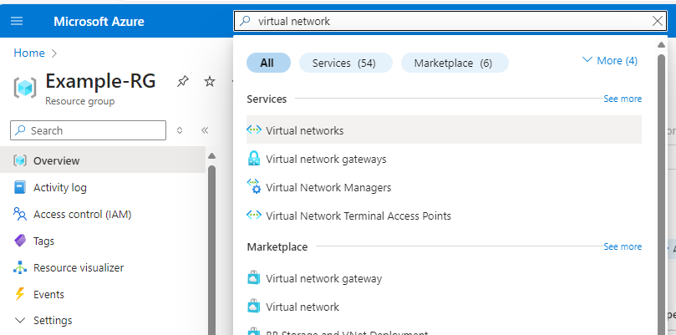

# **Click on the "Create" button to create a new Virtual Network.**

* Enter a name for the Virtual Network.
* Select a subscription for the Virtual Network.
* Select a resource group for the Virtual Network or create a new one.
* Select a region for the Virtual Network.

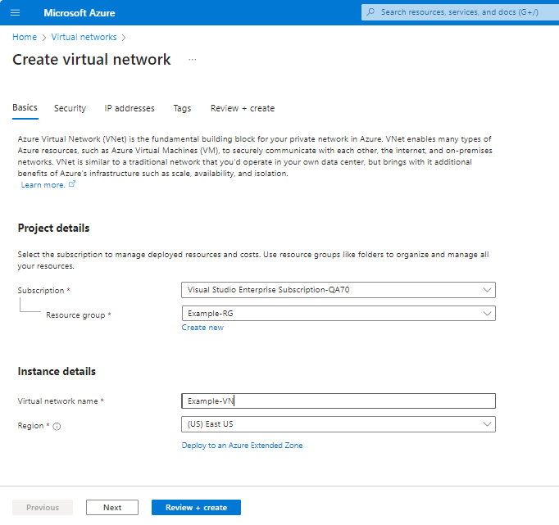

# **Configure the IP address range for the Virtual Network.**

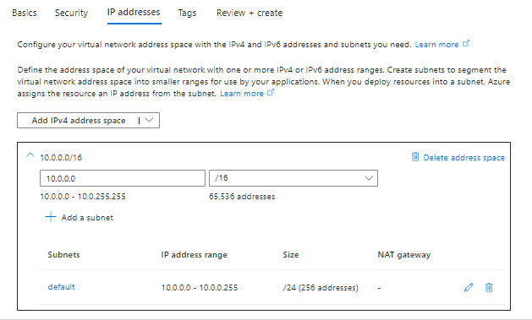

# **Click on the "Add" button to add a new subnet.**

* Enter a name for the subnet.
* Configure the IP address range for the subnet.

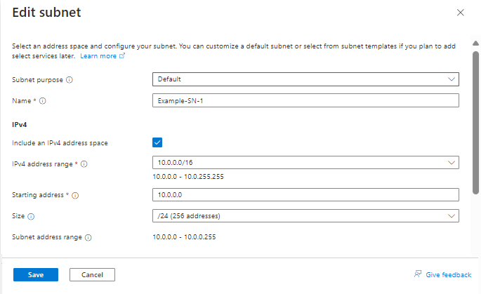

# **Click on the "Review + create" button to review the details of the Virtual Network.**

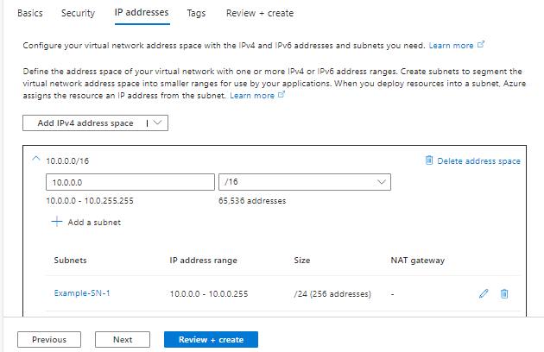

# **After reviewing the details, click on the "Create" button to create the Virtual Network**



 